AUDIOBOOK PLANS & WEBSITE

PUBLISHING & MARKETING

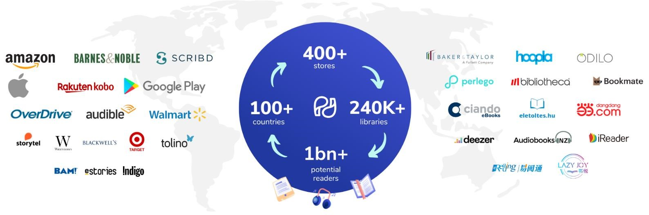

# Premium Narrator Plan – $999

* Narrator (100 Published Audiobooks)
* Studio Recording (Dolby Sound Quality + 4K Sound)
* ACX Account Creation
* Publishing on Audible, Spotify Google Books and Apple Books
* Audiobook Promotion

***Complete Author Website Package*** – **$750**

* Creation, deployment and management
* Domains, hosting and security included
* 5-page WordPress
* Book integration
* Blog integrations

***Complete Search Engine Optimization***

* On-page optimization
* Off-page optimization with 10 backlinks to high authority domains

*These Offers and Packages are a limited time offer and are available during the current month and will not be continued on the exact same pricing the following month. All Packages are subject to revisions in price at the end of every month. Once the desired plan has been purchased on the particular month’s tariff, the customer is not eligible for any extra costs.*